Human Input/output - Vision
Human visual perception can be divided into two stages:
- Physical reception of light
- Processing and interpretation

The human visual system has both strengths and weaknesses:
- Certain things cannot be seen even when present
- Processing allows images to be constructed from incomplete information

The Human Visual System
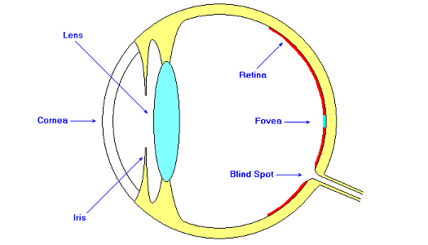
The eye converts light into electrical energy.
Light passes through the cornea and is focussed by the lens, producing an inverted image on the retina.
The iris regulates the amount of light entering the eye.
The retina is covered with photoreceptors. These are of two types:
rods | High sensitivity to light
 | Monochrome
cones | Limited sensitivity to light
 | Colour (red, green blue)
 | High resolution
The eye contains:
- around 6 million cones, most of which are situated within the fovea.
- around 120 million rods, most of which are situated around the periphery of the retina.
The lens is flexible and can focus the image on different parts of the retina.
This makes it possible to adapt between light and dark conditions:
- in bright conditions, light is focussed on the fovea, giving high resolution and colour vision.
- in dark conditions, focus is shifted onto the periphery, giving greater sensitivity but reducing resolution and colour perception.
The retina contains ganglion cells which perform some local processing of images.
There are two types of ganglion cells:
- X-cells
  - Perform basic pattern-recognition.
  - Mainly concentrated in the fovea.
- Y-cells
  - Perform movement-detection.
  - More widely distributed than X-cells, and predominate in the periphery.
The photo-receptors and ganglion cells are all connected to the optic nerve, which carries visual information to the brain.
There are no photo-receptors in the area of the retina around the optic nerve.
Thus there is a blind-spot at this point.
We are not usually aware of the blind spot because our brains 'fill in' the missing part of the image.

Distance Perception
A small object that is close by may have the same visual angle as a larger object that is further away.

However, we are good at gauging the size of objects, even when we see them at extremes of range.
Clearly, visual angle alone does not determine perceived size.
Factors affecting our judgement of size include:
- Stereo vision - the difference in the image seen by each eye can be analysed to gauge distances
- Head movement - small changes in viewing position produce changes in view that allow distance to be gauged
- Monocular Cues:
  - Relative size
  - Relative height
  - Relative clarity
  - Interposition
  - Linear perspective
  - Texture gradient
  - Relative motion
  - Familiarity

Brightness
Luminance is a physical property that can be measured.
The luminance of an object depends on:
- The amount of light falling on to its surface
- The reflective properties of the surface(s).
Contrast is related to luminance. It is the difference in luminance between the brightest and darkest areas of an image.
Perception of brightness is subjective.
The human visual system compensates for bright or dark conditions by varying the relative percentage of rods and cones it uses.
Thus it is difficult to measure/quantify human perception of changes in brightness.
However, we can measure the just noticeable difference (JND) under various conditions.

Increasing the brightness:
- improves visual acuity, but also...
- increases perception of flicker - flicker may become obvious even at higher frequencies.

Colour Perception
Human perception of colour can be modelled using the following three scales:
- Hue - the spectral wavelength of the light
- Saturation - the amount of whiteness in the light
- Brightness (or Intensity)
This is referred to as the HSB model.

Humans can differentiate approximately 150 hues.
When Saturation and Brightness are taken into account, the number of colours that can be distinguished is around 7 million.
RGB displays and CMY(K) printing systems can handle a wide range of colours, but these do not fully coincide with the range of colours the human eye is capable of perceiving.
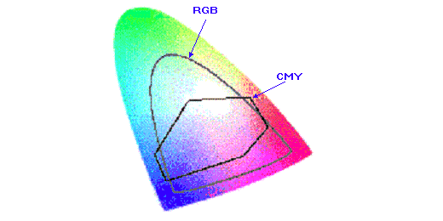
Colour sensitivity is greatest in the fovea, where cones predominate.
Only around 3-4% of the cones are sensitive to blue light. Therefore, discrimination between different shades of a colour is worse for blue than for the other colours.

Also, around 8% of males and 1% of females have some form of colour-blindness (usually red-green blindness).

Reading
The reading process involves the following stages:
- Identify a word or character
Studies show that long words are recognised as quickly as single characters.
This suggests that words are recognised by shape rather than by identification of characters.
- Guess the meaning of the phrase or sentence
- Confirm or disprove the guess
The reader jumps forward through the text, looking for words or characters that will confirm or disprove the guess.
Forward jumps are known as saccades.
- Revise the guess if necessary
If the guess cannot be confirmed, it may be necessary to back-track and revise the guess.
Backward jumps are known as regressions.
Adults typically read printed material at around 250 words per minute.
The legibility of a piece of text can be judged by measuring the average time taken to read it.
Other methods of measuring the readability of text:
- Fog Index (Gunning, 1952)
  - Takes into account word-length, sentence-complexity, etc..
  - Based on the system used to grade reading-exercises in American schools
  - Grades texts on a scale from 6-17, indicating the age at which pupils should be able to read text of the specified complexity.
- Cloze Technique (Taylor, 1953)
  - Subjects are asked to read a piece of text in which every fifth word is blanked out.
  - The index is based on the percentage of blanked words that are guessed correctly.
  - Texts with simple, predictable structures usually obtain high scores
Factors that affect the readability of text include:
Font-style and capitalisation |  | Pattern-recognition is crucial to reading, so type-faces with distinct patterns are easier to read than others.  Block capitals are particularly hard to read.
Font size |  | Font sizes from 9-12 point are equally legible (assuming proportional spacing); larger and smaller sizes are less legible.
Character spacing |  | Proportionally-spaced text is easier to read than text with fixed-spacing.
Line length |  | Lengths of between 2.3" (58mm) and 5.2" (132mm) are equally legible.
Contrast / Luminance |  | Black text on a white background is easier to read than (e.g.) white text on a black background.
Research shows that people:
- Read from a computer screen around 25% more slowly than from printed material.
- 'scan' material on screen more than they do printed material.
- Dislike scrolling
- Dislike 'wordy' text
Morkes and Nielsen (1997) asked subjects to rate several versions of a web-page for usability.
They used an American tourist-board page, and created several versions which contained the same information but presented and/or worded differently.
The ratings given to the various versions (compared with the original) were as follows:
abbreviated text | rated 58% better
text split into single lines | rated 47% better
objective language only | rated 27% better
A version of the page that combined all three approaches was rated 124% better than the original.

